Dataset 8: Time Pressure & Perception Accuracy

Scenario Overview
Students completed a degraded-stimulus perception task under different time limits. Accuracy (%) was recorded for each time condition. The line graph shows accuracy across ordered time bins.

Data Summary
Label | Accuracy (%)
2 s | 90
4 s | 84
6 s | 78
8 s | 71
10 s | 66

Figure
Figure 1. Accuracy (%) across time-allowed conditions.
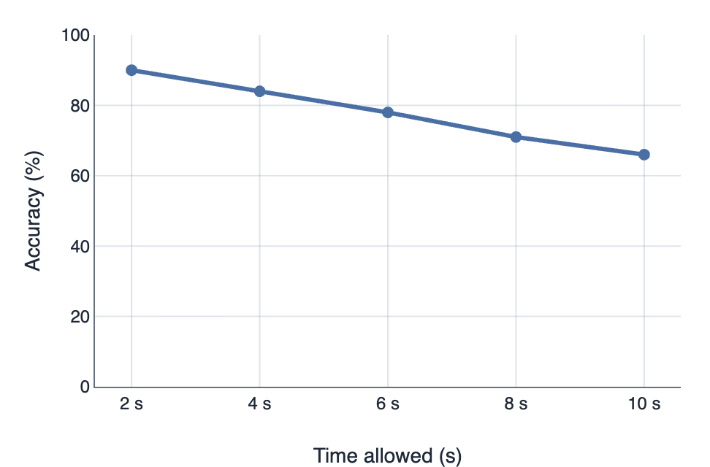

IA1 Practice Questions
- Determine: Determine the accuracy at the 6-second condition.

- Calculate: Calculate the percentage change in accuracy from 2 s to 10 s.

- Identify: Identify the overall trend across time conditions.

- Sequence: Sequence the conditions from best to worst accuracy.

- Infer: Infer what the pattern suggests about time pressure and perceptual processing.

- Predict: Predict the likely accuracy if the time allowed increased to 12 seconds.

